**Steps For ChatBot Creation**

**1.In the IBM Cloud Catalog , navigate to the Services and provision an instance of Watson Assistant.**

**2.Launch the Watson Assistant service.**

**3.Click Create Assistant and follow these detailed instructions for how to create an assistant.**

**4.Name the Watson Assistance instance COVID-19 Assistant or Any name of your choice.**

**5.Click Add dialog skill to the assistant. Follow the documentation if you have questions.**

**6.Click Import Skill > Choose JSON file and import the Covid Json file.**

**7.Go back to All Assistants page. From the action menu , click Settings.**

**8.Go back to your dialog skill and click on the Preview Link button on the side to get a link to test and verify your assistant.**

**9. Your chatbot is ready.**

**(Sample Questions Are Mentioned in the end)**

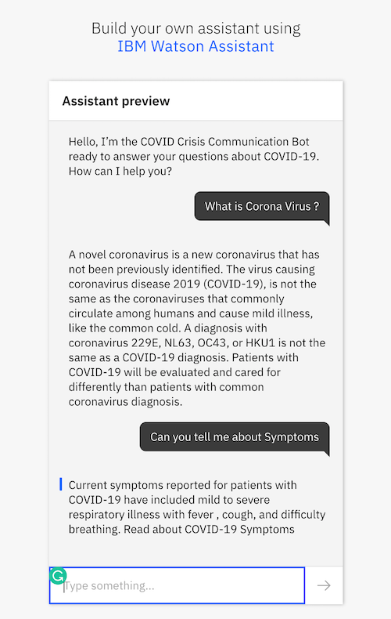

**Sample Questions**

Good morning

Good afternoon

heya

aloha

buenos dias

ciao

hey

hello

Olla

namaste

Hola

How many Cases in US?

What is a quarantine?

Can I catch it from my friend?

Is corona virus contagious?

How does the virus spread?

What is the incubation period of this corona virus?

How did the virus spread from China?

Should I use soap and water or a hand sanitizer to protect against COVID-19?

How do i wash my hands correctly?

Will frequent handwashing help?

Will washing my hands help protect me?

handwashing products

Is hand sanitizer effective against covid-19?

What is in the NEWS?

Whats happening

Is this information accurate?

How do you know this?

Where did you learn this?

Is this true?